**AND GATE**

**OR GATE**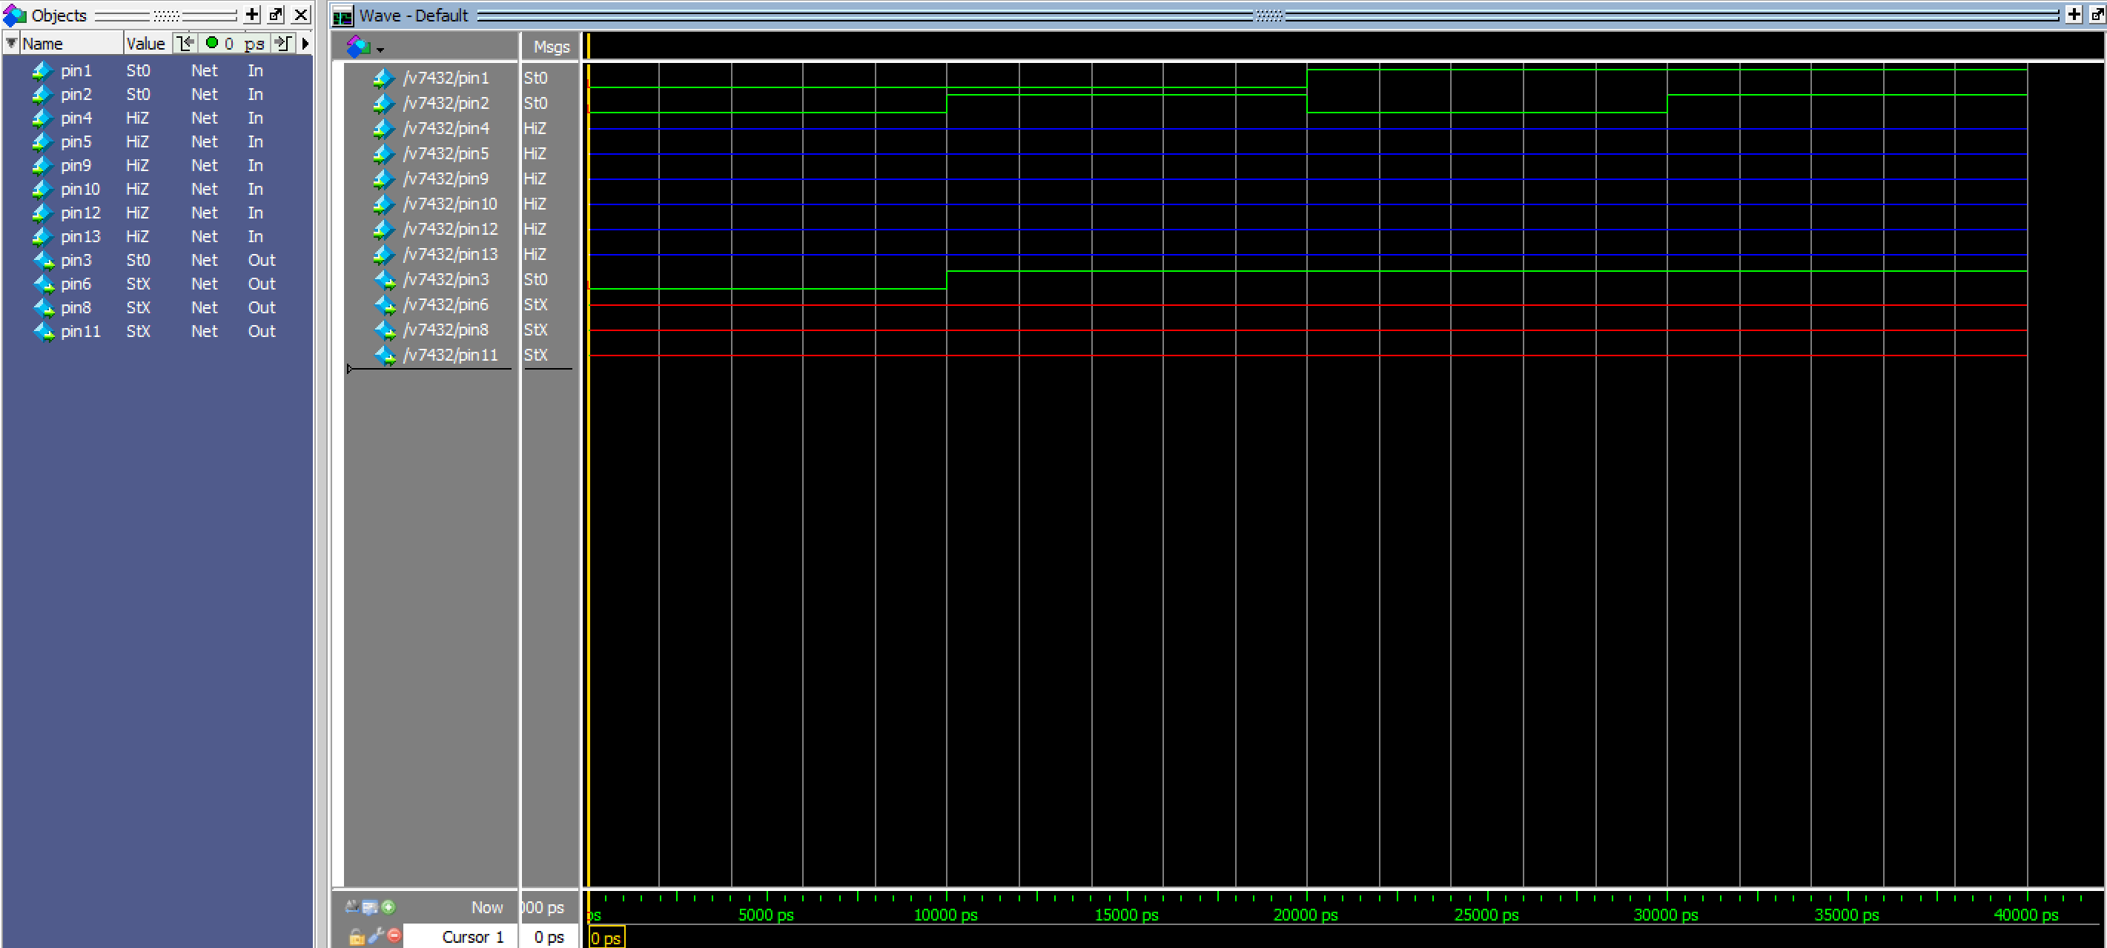

**HEX DECODER**



